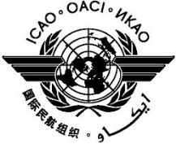 | International Civil Aviation Organization  Fifth Meeting of the Asia Pacific Regional Aviation Safety Team (APRAST/5)  Bangkok, Thailand, 16 to 19 September 2014

Agenda Item x: | Xxx

TITLE

(Presented by State/International Organization)

SUMMARY

Text.

1. INTRODUCTION

1.1 Text.

1.2 Text.

2. DISCUSSION

2.1 Text.

2.2 Text.

3. ACTION BY THE MEETING

3.1 The meeting is invited to:

- Text;
- Text.

3.2 Text.

— END —

